Task 1

Task 1: Scan Your Local Network for Open Ports

Objective: Learn to discover open ports on devices in your local network to
understand network exposure.
Note: To complete the objective, I took the following steps.
Step 1: Open VirtualBox, and then open Kali Linux ios file.
Step 2: To find your local IP both in kali and PC
Open a terminal type “ipconfig” in windows and “ifconfig” or “ip addr” command in kali linux.
Screenshot:
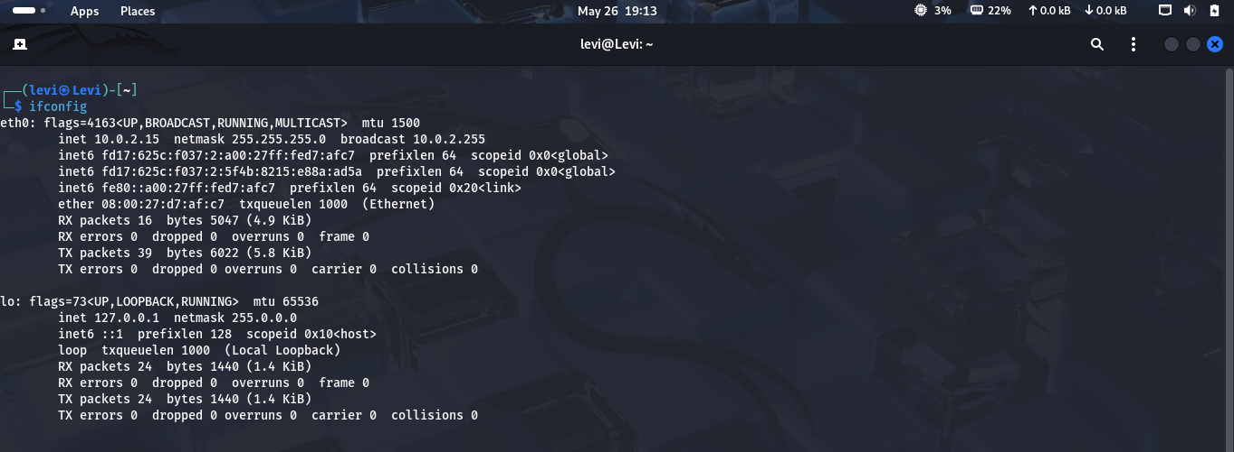
Ifconfig command
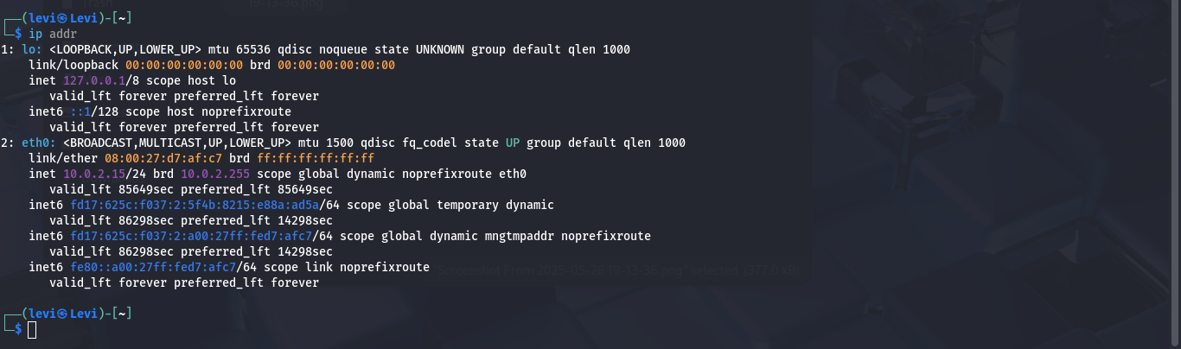
Ip addr Command

Step 3: Open Nmap, then do TCP SYN scan
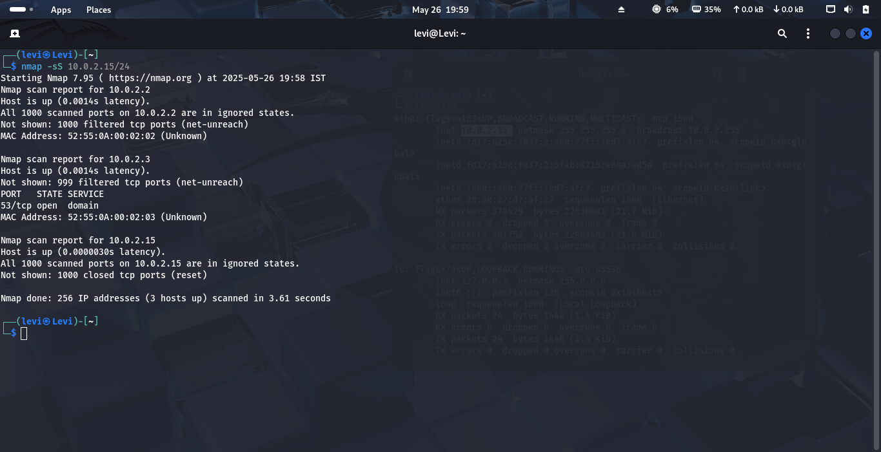
Nmap -sS 10.0.2.15/24(TCP SYN Scan)

The output:
──(levi㉿Levi)-[~]
└─$ nmap -sS 10.0.2.0/24
Starting Nmap 7.95 ( https://nmap.org ) at 2025-05-26 20:02 IST
Nmap scan report for 10.0.2.2
Host is up (0.00057s latency).
All 1000 scanned ports on 10.0.2.2 are in ignored states.
Not shown: 1000 filtered tcp ports (net-unreach)
MAC Address: 52:55:0A:00:02:02 (Unknown)

Nmap scan report for 10.0.2.3
Host is up (0.00055s latency).
Not shown: 999 filtered tcp ports (net-unreach)
PORT STATE SERVICE
53/tcp open domain
MAC Address: 52:55:0A:00:02:03 (Unknown)

Nmap scan report for 10.0.2.15
Host is up (0.0000030s latency).
All 1000 scanned ports on 10.0.2.15 are in ignored states.
Not shown: 1000 closed tcp ports (reset)

Nmap done: 256 IP addresses (3 hosts up) scanned in 2.74 seconds

Step 4: Research common service run on those port.
To find the service run on the port, I use nmap -sV 10.0.2.15/24 (service and Version) or nmap -A 10.0.2.15/24 (Aggressive Scan)
Screenshot:
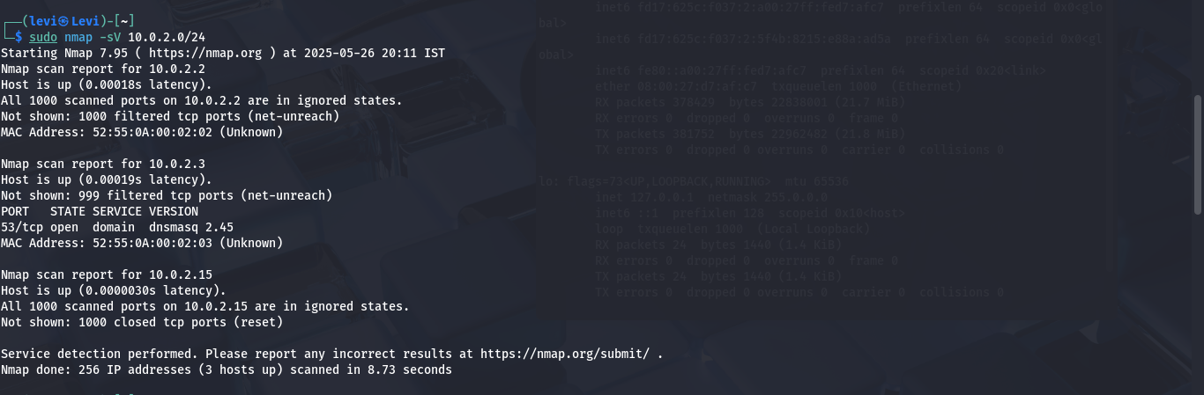
nmap -sV 10.0.2.15/24
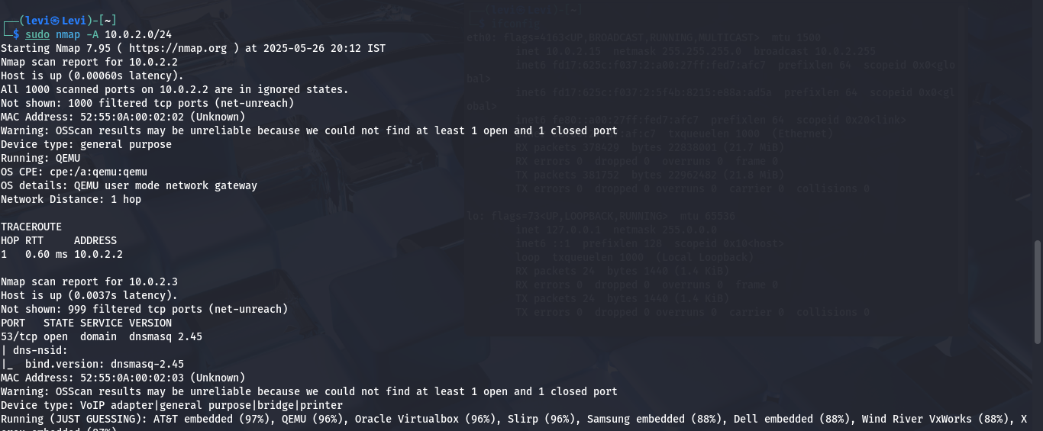
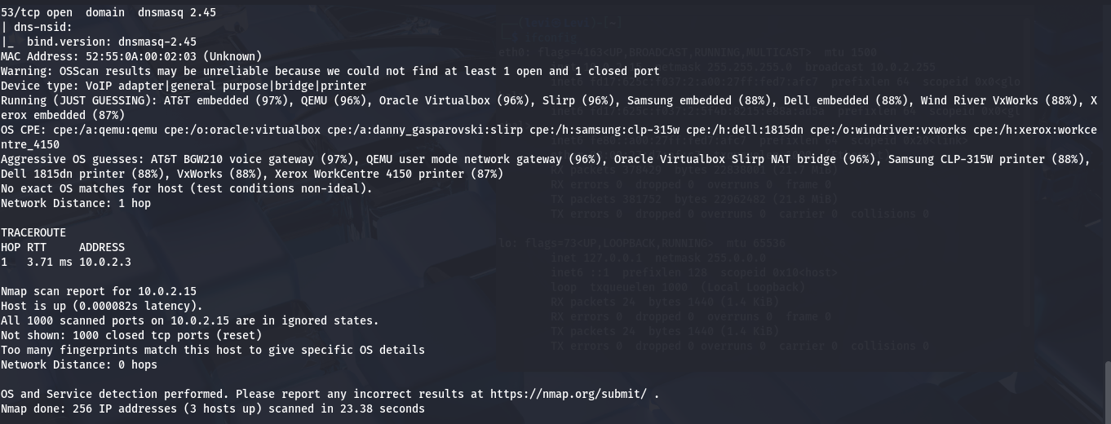
nmap -A 10.0.2.15/24
Step 5: Identify the Potential Risk of open ports.
- Unauthorized Access
- Malware Infections
- Data Exfiltration
- Denial-of-Service (DoS) Attacks
- Misconfigured Services
These are the potential risk in open ports.
Step 6: Wireshark scan
- Capture Network Traffic
- Detect Suspicious Activity
- Identify Risks
Screenshot:
Below we can see the screenshot of the task perfomed using wireshark
